Aškerčeva cesta 6
1000 Ljubljana, Slovenija
Telefon 00386 1 47 71 200
fax 00386 1 25 18 567
dekanat@fs.uni-lj.si

Prošnja za opravljanje obveznosti višjega letnika

Spodaj podpisani………………………………………………z vpisno številko ….…………………...
vpisan v 1. letnik doktorskega študija na Fakulteti za strojništvo Univerze v Ljubljani, z okvirnim naslovom teme doktorske disertacije ………………………………………………………………….
………………………………………………………………………………………………………………,
prosim, da mi omogočite opravljanje vseh študijskih obveznosti za 2. letnik doktorskega študija - III. stopnje.

Ime in priimek Podpisi
Kandidat(ka)………………………………………… ………….…………
Okvirni mentor……………………………………… Se strinjam / Se ne strinjam ………………….…
Okvirni somentor…………………………………… Se strinjam / Se ne strinjam ………………….…
Vodja laboratorija…………………………………… Se strinjam / Se ne strinjam …………………….

Datum in kraj: …………………………

Pomembno: v primeru izpolnjevanja pogojev za vpis v 3. letnik, študent ob koncu 1. letnika (do 31. avgusta) odda vlogo za hitrejše napredovanje.

Glede na 47. člen Pravilnika o doktorskem študiju UL, FS se kandidatu šolnina zaračuna za vsa 4 leta.

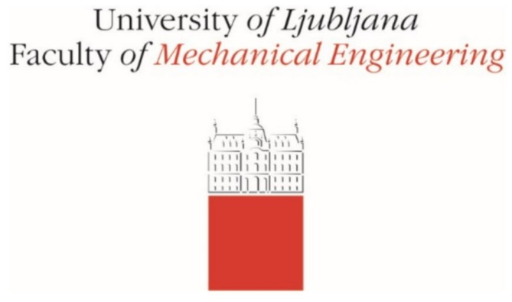 | Aškerčeva cesta 6  1000 Ljubljana, Slovenia  Telefon 00386 1 47 71 200  fax 00386 1 25 18 567  dekanat@fs.uni-lj.si

Application to complete advanced-year requirements

I, the undersigned ……………………………………………, with student number ….…...…………,
enrolled in the 1st year of the third-cycle doctoral study programme in Mechanical Engineering at the Faculty of Mechanical Engineering, University of Ljubljana, with an indicative title for the doctoral dissertation ………………………………………………………………….…………………...,
kindly ask that you allow me to complete all study requirements for the 2nd year of the third-cycle doctoral study programme in Mechanical Engineering.

Name and surname Signatures
Candidate …………………………………. ………….…………………………
Indicative mentor………………………….. I agree / I disagree ………………………………….…
Indicative co-mentor………………… ..…. I agree / I disagree ………………………………….…
Head of Laboratory ………………………. I agree / I disagree ………………………………….…

Date and place: …………………………
Note: If all study requirements for advancement to the 3rd year have been completed, the student may file an application for accelerated advancement at the end of the 1st year (by 31 August).

Based on Article 47 of the Rules on PhD studies of the Faculty of Mechanical Engineering, University of Ljubljana, the tuition fee is charged to the candidate for all 4 years.

