UNIVERSITY OF LJUBLJANA
Faculty of Mechanical Engineering

Title of Faculty of Mechanical Engineering Doctoral Thesis

Doctoral Thesis

Submitted to the Faculty of Mechanical Engineering of the University of Ljubljana to obtain the scientific title of Doctor of Science

Janez Novak

Ljubljana, August 2013

UNIVERSITY OF LJUBLJANA
Faculty of Mechanical Engineering

Title of Faculty of Mechanical Engineering Doctoral Thesis

Doctoral Thesis

Submitted to the Faculty of Mechanical Engineering of the University of Ljubljana to obtain the scientific title of Doctor of Science

Janez Novak

Mentor: prof. dr. Franc Horvat, BSc (Eng)
Co-mentor: prof. dr. Anton Kovačič, BSc (Eng)

Ljubljana, August 2013

Space for decision on the confirmed doctoral thesis topic by the UL.

Acknowledgment
Acknowledgment or inscription is optional.

Write an acknowledgment to those who have helped you with your thesis and without whom the thesis wouldn’t be as it is. Usually, the mentor, co-mentor and the institution that have financially or otherwise supported the preparation of your doctoral thesis should be acknowledged first, followed by assistants, other co-workers and your colleagues who have helped with the theoretical and experimental part. At the end, we usually thank our families.

Abstract
UDK 123.45:678.91:234.56(789.1)
No.: DR III/99

Title of Faculty of Mechanical Engineering doctoral thesis

Janez Novak

Key words: template
doctoral thesis
instructions
content
graduation
regulations

The abstract starts with a condensed description of the discussed issue, followed by a description of the selected methodology and most important results or findings without additional explanation. The abstract shall be no greater than 200 words.

Abstract
UDC 123.45:678.91:234.56(789.1)
No.: DR III/99

Title of Faculty of Mechanical Engineering doctoral thesis

Janez Novak

Key words: template
doctoral thesis
instructions
content
graduation
regulations

English translation of the abstract

Table of Contents

Table of Figures xiii
Table of Tables xv
List of abbreviations xvii
List of abbreviations xix
1. Introduction 1
1.1. Doctoral thesis template instructions 1
1.1.1. Using pre-set styles in template 1
1.1.2. References to parts of the text 2
2. Theoretical basis 4
3. State of development overview 6
3.1. Content 6
3.1.1. Information sources 6
3.2. Subchapters and styles 6
3.2.1. 2nd level subchapter 6
3.2.1.1. 3rd level subchapter 6
3.2.1.2. Use of bold, italics and underlined text 7
3.2.1.3. Enumeration levels 7
3.3. Tables 8
3.4. Figures 9
3.5. Equations 12
3.6. Citing and references 13
3.6.1. Examples of references 14
4. Purpose and objectives of doctoral thesis 16
4.1. Presentation of the problem 16
4.2. Hypothesis and objectives 16
4.3. Thesis course 16
4.4. Publications 16
5. Research methodology 18
5.1. Recalculations 18
5.2. Experimental part 18
5.2.1. Samples and materials 18
5.2.1.1. Gear pair 18
5.2.1.2. Shaft 19
5.2.2. Testing methodology 19
5.2.2.1. Gear testing 19
5.2.2.2. Displacement measuring device (LVDT) 19
5.2.3. Analysis of deformation mechanisms 19
5.3. Correlation of recalculations and experimental results 20
6. Results 22
7. Discussion 24
8. Conclusions 26
9. References 28
10. Appendix A 30
11. Appendix B 32

Table of Figures
Figure 3.1: Image taken with electronic microscope [2]. 11
Figure 3.2: Schematic presentation of polymerisation procedure [2, 3]. 11
Figure 3.3: (a) Dependency of the share of missed shots at a competition in terms of the training time dependency before the competition. (b) Deformation in dependency in terms of load time for two different samples. 12
Figure 3.4: Time sequence of a projectile drop in water from height (a) 2,.1 m; and (b) 4.1 m [4]. 12

Table of Tables
Table 3.1: Effectiveness of various water polluter removal processes. 9
Table 3.2: Cumulative values of water consumption at all UF units for 2012 [1]. 10

List of abbreviations
Mark | Unit | Meaning
A | m² | surface
C | / | concentration
D | m² s⁻¹ | diffusion coefficient
d | mm | diameter
P | Pa, bar | pressure
V | m² | volume
v | m s⁻¹ | velocity
γ | m² l⁻¹ | clogging increase
ε | / | recovery
η | Pa s | dynamic viscosity
Indexes
cel | total
f | filtration
k | concentrate
p | permeate
z | initial

List of abbreviations
Abbreviation | Meaning
ACH | Aluminium Chlorohydrate, type of coagulant
COD_{Mn} | Chemical Oxygen Demand, using potassium permanganate as oxidizing agent
GAC | Granular Activated Carbon
MF | Microfiltration
NF | Nanofiltration
PAC | Powder Activated Carbon
RO | Reverse Osmosis
SCADA | Supervisory Control and Data Acquisition
TOC | Total Organic Carbon
TSS | Total Suspended Solids
UF | Ultrafiltration

Introduction
The introductory chapter shall contain the general description or explanation of the discussed topic. Present the starting points of your doctoral thesis, the issues discussed and its meaning. Don’t present the results and decisions in the introduction.

Doctoral thesis template instructions
The part of the text that the student shall change to match his or her information and information about his or her doctoral thesis is coloured in red in the template’s non-content part of the doctoral thesis (up to page xxii). When the thesis is prepared, the Table of Contents, the Table of Figures and the Table of Tables only shall be updated, taking into consideration the instructions in Chapter 2. Using pre-set styles in template. The entire text of the final doctoral thesis (including the non-content part – until page xxvi) shall be coloured black.

Instructions and examples of doctoral thesis design are provided in the content part of the doctoral thesis template. Students shall replace the entire text, the main headings, with the corresponding text for their doctoral thesis.

Using pre-set styles in template
Use this template, containing pre-set styles to unify the final form of doctoral theses at the FME, to write the doctoral thesis.

In 'Home' -> 'Styles', choose:
- 'Normal' for the major body of the text;
- 'Pre-chapter' for headings in the formal part of thesis on pg. v–xxii (e.g. Abstract);
- 'Heading 1' for main headings (e.g. 1. Introduction);
- 'Heading 2' for 2nd level heading (e.g. 3.5. Equations);
- 'Heading 3' for 3rd level heading (e.g. 3.6.1. Examples of references);
- 'Heading 4' for 4th level heading (e.g. 3.2.1.1. 3rd level subchapter);
- 'List Paragraph' to provide indents – see 3.2.1.3. Listing levels (3 pre-set indent levels);
- 'Conclusions' to provide conclusions in Chapter 8. Conclusions; and
- 'References' to provide references in the list of literature; if you’re using the citation programme, adapt the literature list to this style.

For figure and table names (and equation numbering) use automatic numbering by opting for 'References' -> 'Insert caption' under the figure, or above the table and choose 'Figure' for figure name, or 'Table' for table name in 'Label'. This enables simple automatic figure and table numbering, e.g. you don’t need to manually correct numbering if you insert a new figure or table in the text, and simple preparation of a list of figures or tables: at the end of doctoral thesis preparation, right click the List of Figures and the List of Tables and choose 'Refresh field', so the lists are automatically refreshed. Similarly, refresh the Table of Contents by right clicking the table of contents field and choose 'Refresh field'.

To insert an equation, such as equation (3.2) in chapter 7.4. Equations, it’s recommended you first save a new equation style in the following manner: first mark the entire equation row in this template, e.g. (3.2), and in 'Insert' choose 'Equation', after which choose 'Save Selection to Equation Gallery'; then, in the window that opens in the field 'Name', insert the desired name, for example, 'Equation with numbering'; next, choose 'Equations' in 'Gallery' and 'General' in 'Category', leaving the remaining fields unchanged; finally, confirm entry of the new equation style. Now you can insert the new equation into the text by choosing 'Equation' in 'Insert' and afterwards choosing the option 'Equation with numbering' to insert a 2-column table with sample equation and numbering.

References to parts of the text
Word doesn’t enable the declension of text when directly referencing figures and tables, which is why we recommend the following method for referencing figures, tables and other parts of the text. When you insert a figure name, e.g. 'Figure 2.1: Example of figure…', mark the figure number in the figure name (in this case 2.1) and choose ‘Bookmark’ in 'Insert; then enter the name which you will use to recognise this bookmark n 'Bookmark name'; next, choose ‘Cross-reference’ in ‘References’ in the part of the text where you want to insert the reference to Figure 2.1; now choose 'Bookmark' in 'Bookmark type', then choose 'Bookmark text' in 'Insert reference to' and choose the suitable bookmark in the menu. In this way, you will save references, even if you insert new figures, tables, and the like, in the text.

You can similarly reference chapter names, for example, the numbered parts of the text, equations and other sets of text, using the option 'References' -> 'Cross-reference' by choosing 'Heading' in 'Bookmark type', then the desired option in 'Insert reference to' and then the desired name for reference.

Theoretical basis
If the discussed topic is closely connected to a broader scientific field or knowledge related to specific phenomena, processes, procedures, recalculations and the like not directly discussed by the doctoral thesis but important for its understanding, a chapter Theoretical basis can be inserted after Introduction; this is where the broader topic, assumptions, scope of existing methods, models and procedures, and their limitations and relevance for the doctoral thesis are presented. This chapter is also used, for example, if the scope of the State of development overview on which the doctoral thesis is based is still relatively small and a slightly broader explanation is needed for a better understanding of the discussed topic. The chapter title can be adapted to the discussed topic.

This chapter is not a mandatory and can be partly or fully included in the State of development overview.

State of development overview

Content
Regardless of whether the doctoral thesis is theoretically- or experimentally-focused, the theoretical basis of the discussed topic must first be discussed.

Information sources
Books and, most of all, expert and scientific articles shall be the main sources of information when reviewing literature. We recommend using Dikul, Web of Science, ScienceDirect and Google Scholar when searching for online articles and other literature.

Read more about resource citation in the continuation of this template.

Subchapters and styles
Divide individual parts appropriately into consecutively numbered subchapters. The format and style of titles should correspond to those presented in this template. Enumeration should be automatic, as presented in this template. Use this template directly to write your doctoral thesis because all styles are pre-set, including ordinary style, style for chapters and subchapters, style for names of tables and figures.

2nd level subchapter

3rd level subchapter
The first line of paragraphs shall not be indented and there shall be one empty line between paragraphs. There should be two empty lines of spacing between the subchapter title and the end of the preceding text. If the subchapter title starts immediately after a higher-level subchapter title, there should be no empty lines between the two titles. Use a maximum of four title levels, that is the main title plus three subtitle levels.

Additional text spacing

If you wish to additionally separate individual parts of the text at the final, 4th subchapter level, you can use one line of bold text (Times New Roman font size 12 pt), which should be separated by two empty lines from the preceding text, or without spacing if it directly follows the subchapter title; the following text should be separated with one empty line.

Use of bold, italics and underlined text
In addition to the previous example, the use of bold text is permissible where:
- we mention and define a very important term for understanding the thesis in the text for the first time;
- we want to specifically point out a part or thought: and
- we want to visibly separate individual parts of the text, such as enumeration.

When we use foreign language words in the text, we use the italics. Underlined text is not usually used.

Enumeration levels
Regardless of how many hierarchical indent levels are used for enumeration in the text, though usually not more than two, we always use the same combination and method of marking individual indent levels to achieve unified text appearance.

1st level indents are marked with “-“, which is aligned to the left with the page/text margin, and the text of the 1st level of enumeration follows 0.5 cm from the left page margin. 2nd level indents are marked with “-“, which is 0.75 cm away from the left page margin, and the text that follows is 1.25 cm away from the left page margin. An example is presented below:
- 1st level example:
- 2nd level example,
- 2nd level example,
- 1st level example:
- 2nd level example,
- 2nd level example.

There should be one empty line of spacing after the previous indent to the next paragraph, or two empty lines of spacing if the previous indent is followed by the title of a new chapter.

Tables
Tables shall be consecutively numbered, starting with the number of the 1st level chapter where the table is placed, followed by the consecutive number of the table in this chapter. The table should be centred. An example is presented in Table 3.1.

The table name, consequent number and brief description shall be placed under the table aligned with the left text margin. The font for the name with the table’s consecutive number shall be Times New Roman font size 11 pt, and it shall include the character “:” after the table’s consecutive number. The brief table description in Times New Roman font size 11 pt shall start with an upper case letter and end with a final punctuation mark. There shall be one empty line between the text and table name, such as in Table 3.1, unless the table name is at the very top of page. The table name’s is pre-set in the template. There should be no empty line between the table name and the table. There shall be two empty lines between the table and text continuation, see Table 3.2.

Table 3.1: Effectiveness of various water polluter removal processes.
Process | Removal of microorganisms | Removal of suspended substances | Removal of dissolved inorganic substances | Removal of dissolved organic substances
Biological
Active mud | + | + | - | +
Anaerobic processing | - | + | - | +
Biofilters | - | - | - | +
Chemical
Chlorination | + | + | - | +
Ozoning | + | + | - | ο
Coagulation | + | + | - | +
Physical
Activated carbon adsorption:
granular | - | + | - | +
powder | + | + | - | +
Conventional filtration | - | + | - | -
Flocculation + sediment. | + | + | - | -
Membrane processes
MF | + | + | - | -
Legend: + = removal process is effective ο = removal process is partial, - = removal process not in place.

If the table or a part thereof is taken from another source, it must be cited. If the entire table is taken from elsewhere, the reference number is added to the table description. If only certain values or text in the cells are taken from elsewhere, this can be cited in individual cells or at the end of an individual line.

Tables shall be readable, clear and transparent; to these ends, it is recommended that students use Times New Roman minimum font size 10 pt. Under the table or figure, possible remarks and legends in a smaller font size, at a minimum of font size 8 pt, can be added, see Table 3.1. References to tables and figures are made in normal text with low case initial letters as with remarks and legends in the previous sentence. All tables and figures shall be previously mentioned in the text and explained in detail.

Table 3.2: Cumulative values of water consumption at all UF units for 2012 [1].
Month | V_{f}  [m³] | V_{sp} + V_{kč,sp}  [m³] | V_{v}  [m³] | V_{p,cel}  [m³] | V_{pov} + V_{kč,pov}  [m³] | V_{p}  [m³] | ε_{UF}  [%]
January | 34785 | 2315 | 37100 | 34785 | 9192 | 25593 | 69.0
February | 28575 | 1574 | 30149 | 28575 | 8743 | 19832 | 65.8
March | 34002 | 1517 | 35519 | 34002 | 8963 | 25039 | 70.5
April | 32118 | 882 | 33081 | 32118 | 7516 | 24602 | 74.4
May | 33949 | 548 | 34497 | 33949 | 7457 | 26492 | 76.8
June | 37004 | 137 | 37141 | 37004 | 7175 | 29966 | 80.7
July | 34276 | 455 | 34731 | 34276 | 7145 | 27131 | 78.1
August | 15621 | 834 | 16455 | 15621 | 3200 | 12421 | 75.5
September | 29969 | 595 | 30564 | 29969 | 7937 | 22032 | 72.1
October | 31468 | 764 | 32232 | 31468 | 8242 | 23226 | 72.1
November | 29033 | 1143 | 30176 | 29033 | 8065 | 20968 | 69.5
December | 31874 | 1260 | 33134 | 31874 | 7463 | 24411 | 73.7

The table should be relevantly positioned in the text. Usually, it is placed below the paragraph where the table is first mentioned; if the table is placed differently for the purpose of text formatting, it shall be placed as near as possible to its first mention in the text.

Individual tables and figures are presented on one page if possible; if is not possible because of its size, write “is continued” at the right bottom of each page if the table continues on the next page and “continuation” at the top left side of the subsequent page. The entire header of the table must be placed and columns numbered when necessary on each page.

Figures
Figures shall be numbered consecutively, starting with the number of the 1st chapter level where the figure is located followed by the consecutive number of the figure in the current chapter. Figures should be centred, see Figure 3.1.

The figure name, consequent number and brief description shall be placed under the figure, and centred in relation to the figure and text. The font of the name with the figure’s consecutive number shall be Times New Roman font size 11, and it shall include the character “:” after the figure’s consecutive number. Figure description shall start with an upper case letter and end with a final punctuation mark using Times New Roman font size 11 pt. It is recommended that names and descriptions of figures and tables are kept short because this appropriate from the perspective of subsequent tables of figures and tables preparation. There should be two empty lines between the text and figure, unless the figure is at the very top of page. There should be one empty line between the figure name and the continuation of the text. There should be no empty lines between the figure and figure name. The font size for the figure name is 12 pt, see Figure 3.1. The figure name style is pre-set in this template.

Figure 3.1: Image taken with electronic microscope .

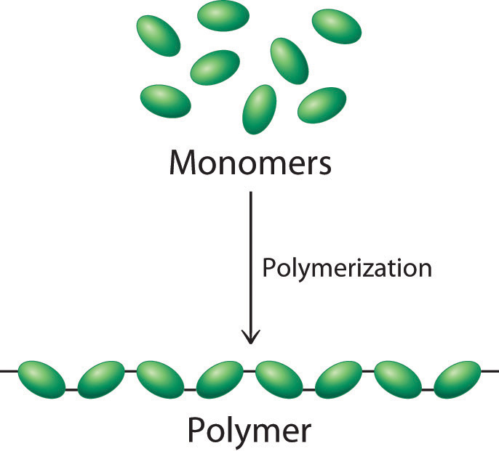
monomeri
polimer
polimerizacija
Figure 3.2: Schematic presentation of polymerisation procedure [2, 3].

Figures shall be readable, clear and transparent. They must be of a good quality and in the Slovenian language. If a figure contains a diagram, the sizes and units of all axes must be clearly and consistently marked. Microscope images shall include a suitably marked length scale. Optically read figures shall have as good a resolution as possible. The figures you prepare with programmes such as CorelDraw, Photoshop, PowerPoint and the like shall be saved in either the *.emf (Enhanced Metafile) or *.eps (Encapsulated PostScript) format to maintain all figure detail when converting the document into the *.pdf format and ensure best printing quality.

Each figures, including Figures 3.2 and 3.3, shall be relevantly placed in the text; usually under the paragraph where it is mentioned for the first time. If a figure is placed differently to ensure better text formatting, it should still be placed as near to its first mention in the text as possible. If two figures are placed one below another, there shall be two empty lines between the first figure name and the second figure name.

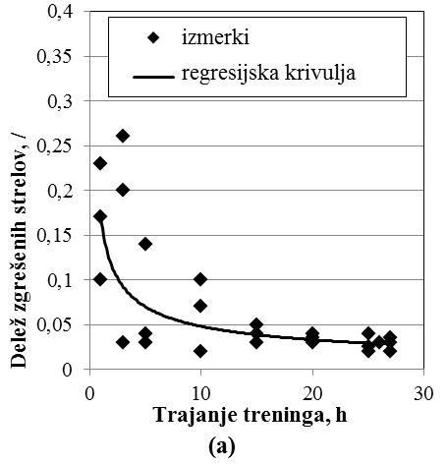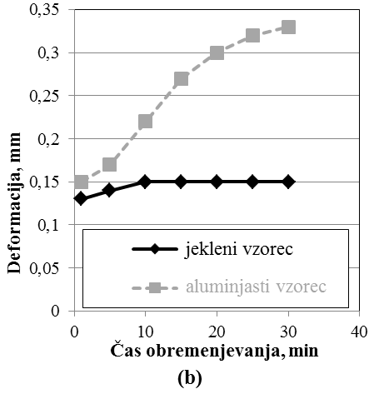
Figure 3.3: a) Dependency of the share of missed shots at a competition in terms of the training time dependency before the competition. (b) Deformation in dependency in terms of load time for two different samples.

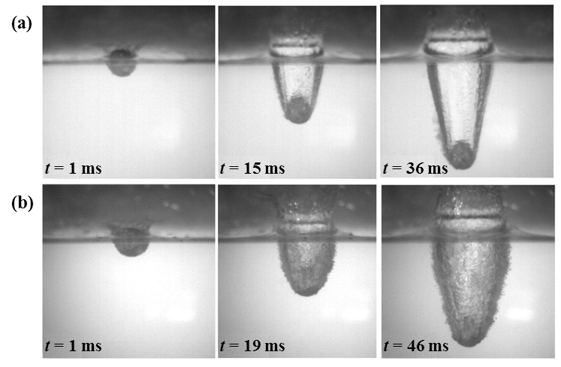
Figure 3.4: Time sequence of a projectile drop in water from height (a) 2.1 m; and (b) 4.1 m [4].

Several connected diagrams can be joined into one figure by clearly separating them into sub-sets as presented in Figures 3.3 and 3.4, that is (a) and (b), thus ensuring transparency.
If a figure is taken from a certain resource, this must be cited as presented in Figure 3.1. All other author figures shall also be cited.

Equations
Equations shall be 0.5 cm left text margin aligned. Equation numbers are provided in the round brackets at the end of the last line where the equation is provided: we recommend using a 2-column table to properly place the equation and its sequence number. Numbering starts with the number of the 1st level chapter where the equation is located, followed by the sequence number of the equation in the current chapter. The equation must be explained in the text.
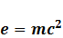 | (3.1)

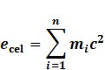 | (3.2)
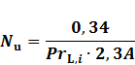 | (3.3)

References to suitable equation numbers, such as equation (3.2), shall be provided in the continuation if necessary.

Quantities and other symbols are usually marked with Latin and Greek alphabet letters, sometimes with the addition of indexes and other characters. As presented in equations (3.2) and Error: Reference source not found, symbols, that is quantity markings, such as e or Pr, are written in italics. There shall be no full stop after a symbol unless a sentence ends with a symbol.

Indexes are usually used when two quantities have the same symbol or if we want to additionally define a quantity, e.g. _{max} as maximum, _{cel} as total, _{z} as initial, and the like. The indexes denoting physical quantities are written in italics, whereas descriptive indexes used to additionally define quantities, such as “cel” in e_{cel} or “L” in Pr_{L,i}, shall be written in normal plain text. Indexes comprised of numbers are also written in normal plain text, whereas indexes of letters denoting counting and numbers, e.g. “i”, m_{i} and Pr_{L,I}, are written in italics.

To correctly provide physical quantities, constants, indexes and other elements in equations, use the “Recommendations for authors of study and expert publications at the Faculty of Mechanical Engineering in Ljubljana” by senior lecturer dr. Stropnik [5].

Citing and references
When citing, observe the rules of citation that not only apply to final papers but also in general for each presentation where the intellectual and material property of other authors is used. We use newer relevant international expert literature as much as possible for reference purposes. Online resources can account for a maximum of 25% of the resources used in the final paper.

All of the literature references used shall be placed in the text using sequence numbers in square brackets, which is why the list of bibliography shall be numbered in accordance with the sequence of citations used in the document. Examples are presented in the following sentences:
- The work of Bažant et al. [1] presents an overview of impacts on construction stability.
- In 2005, Bažant and Cedolin [6] presented the use of modal analysis in construction stability recalculation.
The consecutive number of the resource referenced in the square bracket is repeated in the list of references (see 8. Examples of references), and when later referring to the same reference, the same number is used.

The list of literature used shall be aligned left and formatted in accordance with the examples in this template (see chapters 8. Examples of references and Error: Reference source not found. References) and in general it shall include the following information:
- Author, title of work, publishing house and place and year of publishing if it is a monograph or book;
- Author, chapter title, editor, book title, publishing house, place and year of publishing and number of the first and last page of the chapter if it is a book or monograph chapter;
- Author, title of article, name of journal, journal number, year of publishing and number of the first and last page of the article if it is a magazine article;
- Author, title of contribution, editor and title of collection, place and date of conference or publication of collection, and number of the first and last page of the contribution if it is a conference contribution;
- Author (if known), title of work, online address and access time if it is a resource from a website; and
- Author, title of paper, type of paper, place and year of publishing if it is a doctoral thesis or other final paper.

When referring to a resource with several authors, use “et al.”, for example: The work of Bažant et al. [1] provides an overview of impacts…

Examples of references are provided in the continuation. When listing enumerated and/or other suitable resource information, such as conference reports, patents, standards, regulations, brochures, studies, and other diplomas, you shall also observe the following:
- SIST ISO 690: 1987(E) Documentation – Bibliographic references: Content, form and structure; and
- SIST ISO 690 – 2: 1997(E): Electronic documents or parts thereof.

Examples of references
Books:
- Z. P. Bažant, L. Cedolin: Stability of Structures: Elastic, Inelastic, Fracture, and Damage Theories. Oxford University Press, New York, 1991.
- J. Stropnik: Priporočila avtorjem študijskih in strokovnih publikacij na Fakulteti za strojništvo v Ljubljani. Fakulteta za strojništvo, Ljubljana, 1997.

Book chapters:
- J. Doe: Earthquake stability. In: Z. P. Bažant, L. Cedolin (ur.): Stability of Structures: Elastic, Inelastic, Fracture, and Damage Theories. Oxford University Press, New York, 1991, pg. 124–157.

Journals:
- Z. P. Bažant, L. Cedolin: Noise control. Journal of Sound and Vibration 111 (2008) pg. 42–50.
- J. Gonzalez-Gutierrez, J. L. Carillo-Estrada, J. C. Ruiz-Suarez: Penetration of granular projectiles into a water target. Scientific reports 4:6762 (2014) pg. 1–5.

Conferences:
- Z. P. Bažant, L. Cedolin: Modalna analiza. In: B. Podskrajnik (ur.): Kuhljevi dnevi: Zbornik referatov. Ljubljana, Slovenija, 2005, pg. 2–5.
- Z. P. Bažant, L. Cedolin: Modal analysis. In: S. Smith (ur.): Proceedings of the 22. Congress of Polymers. London, UK, 2007, pg. 3–8.

Online resources with known author:
- C. Kogoj: Modalna analiza: izbrana poglavja iz DTD. Available at: http://lab.fs.uni-lj.si/ldtd/Gradivo_za_studente/DTD/Pregled%20teorije.pdf, viewed: 11. 1. 2012.

Publications of organisations (printer or published on websites):
- Merkur d.d: Letno poročilo podjetja Merkur d.d. Kranj. Merkur d.d., Kranj, 2005.
- Statistični urad republike Slovenije: Statistični letopis Republike Slovenije 2009. Statistični urad Republike Slovenije, Ljubljana, 2009.
- Statistični urad republike Slovenije: Standardna klasifikacija dejavnosti 2005. Available at: http://www.stat.si/klas/tabela.aspx?cvn=1895, viewed: 10. 1. 2012.

Websites of organisations, associations, individuals:
- M Kariera – Zaposlitveni portal. Available at: http://www.mercator.si/kariera, viewed: 10. 1. 2012.

Online bases, encyclopaedias, dictionaries, etc.:
- Engineering. In Encyclopedia Britannica online. Available at: http://student.britannica.com/comptons/article-9274119/engineering, viewed: 8. 1. 2012.
- Poslovna aplikacija. In eSlovar. Available at: http://www.eslovar.com/besedilo.asp?id=1563, viewed: 8. 1. 2012.

Legislation (official gazettes, regulations, standards):
- Zakon o gospodarskih družbah. Uradni list RS št. 42/2006, 60/2006 popr., 26/2007-ZSDU-B, 33/2007-ZSReg-B, 67/2007-ZTFI (100/2007 popr.), 10/2008, 68/2008, 23/2009; Odl. US: U-I-268/06-35.
- Zakon o okoljskih predpisih. Uradni list RS št. 72/2009-UPB2, 65/2010.
- ISO 2573:1977. Tensile testing systems – Determination of K-value.
- DIN 4768:1990. Determination of surface roughness values R_{a}, R_{z}, R_{max}.
- JIS B 0601:2001. Geometrical product specifications (GPS) profile method – Terms, definitions and surface texture parameters.

Doctoral theses and other final papers:
- A. Novak: Izdelava avtomatiziranega stroja za lupljenje krompirja: doktorska disertacija. Ljubljana, 2015.

Purpose and objectives of doctoral thesis

Presentation of the problem
This is where you summarize your key findings and results based on your State of development, especially open issues that have not been resolved.

Hypothesis and objectives
Present the research hypothesis determined when reviewing the State of development, which is the starting point for the doctoral thesis, and concrete objectives to be achieved in terms of the research hypothesis in the context of the doctoral thesis which directly represent a scientific contribution or broader in this chapter. Write what you will do, what you expect from your theoretical and practical research, and risk of not meeting your objectives. Write about hypotheses not results.

Thesis course
Focus on the structure of the thesis in chapters, that is where your content is presented and how content is interconnected, in this section.

Publications
When doctoral thesis results were published or prepared as comprehensive scientific publications, you can provide a list of such publications in this sub-chapter. The Presentation of Publications list is optional.

Research methodology
Based on the type of doctoral thesis, research or developmental, present, explain and reason the applied methods and/or procedures for measurement, calculation, modelling and the like and present and explain the selection of the materials and samples used; provide a detailed presentation of measurement uncertainty in this chapter.

Recalculations
Based on assumptions about … we have recalculated … using the derivation of Bažant et al. [5], who showed … Lorem ipsum dolor sit amet, consectetur adipiscing elit, sed do eiusmod tempor incididunt ut labore et dolore magna aliqua. Ut enim ad minim veniam, quis nostrud exercitation ullamco laboris nisi ut aliquip ex ea commodo consequat. Duis aute irure dolor in reprehenderit in voluptate velit esse cillum dolore eu fugiat nulla pariatur. Excepteur sint occaecat cupidatat non proident, sunt in culpa qui officia deserunt mollit anim id est laborum.

Experimental part

Samples and materials

Gear pair
We have selected … for gear pairing. Lorem ipsum dolor sit amet, consectetur adipiscing elit, sed do eiusmod tempor incididunt ut labore et dolore magna aliqua. Ut enim ad minim veniam, quis nostrud exercitation ullamco laboris nisi ut aliquip ex ea commodo consequat. Duis aute irure dolor in reprehenderit in voluptate velit esse cillum dolore eu fugiat nulla pariatur. Excepteur sint occaecat cupidatat non proident, sunt in culpa qui officia deserunt mollit anim id est laborum.

Shaft
The shaft was produced from… Lorem ipsum dolor sit amet, consectetur adipiscing elit, sed do eiusmod tempor incididunt ut labore et dolore magna aliqua. Ut enim ad minim veniam, quis nostrud exercitation ullamco laboris nisi ut aliquip ex ea commodo consequat.

Testing methodology

Gear testing
We have designed… Lorem ipsum dolor sit amet, consectetur adipiscing elit, sed do eiusmod tempor incididunt ut labore et dolore magna aliqua. Ut enim ad minim veniam, quis nostrud exercitation ullamco laboris nisi ut aliquip ex ea commodo consequat. Duis aute irure dolor in reprehenderit in voluptate velit esse cillum dolore eu fugiat nulla pariatur. Excepteur sint occaecat cupidatat non proident, sunt in culpa qui officia deserunt mollit anim id est laborum.

Lorem ipsum dolor sit amet, consectetur adipiscing elit, sed do eiusmod tempor incididunt ut labore et dolore magna aliqua. Ut enim ad minim veniam, quis nostrud exercitation ullamco laboris nisi ut aliquip ex ea commodo consequat. Duis aute irure dolor in reprehenderit in voluptate velit esse cillum dolore eu fugiat nulla pariatur. Excepteur sint occaecat cupidatat non proident, sunt in culpa qui officia deserunt mollit anim id est laborum.

Displacement measuring device (LVDT)
To measure … we used the linear variable differential transformer (LVDT), thereby ensuring…

Lorem ipsum dolor sit amet, consectetur adipiscing elit, sed do eiusmod tempor incididunt ut labore et dolore magna aliqua. Ut enim ad minim veniam, quis nostrud exercitation ullamco laboris nisi ut aliquip ex ea commodo consequat. Duis aute irure dolor in reprehenderit in voluptate velit esse cillum dolore eu fugiat nulla pariatur. Excepteur sint occaecat cupidatat non proident, sunt in culpa qui officia deserunt mollit anim id est laborum.

Analysis of deformation mechanisms
After testing, we analysed the surfaces with… Lorem ipsum dolor sit amet, consectetur adipiscing elit, sed do eiusmod tempor incididunt ut labore et dolore magna aliqua. Ut enim ad minim veniam, quis nostrud exercitation ullamco laboris nisi ut aliquip ex ea commodo consequat.

Correlation of recalculations and experimental results
Lorem ipsum dolor sit amet, consectetur adipiscing elit, sed do eiusmod tempor incididunt ut labore et dolore magna aliqua. Ut enim ad minim veniam, quis nostrud exercitation ullamco laboris nisi ut aliquip ex ea commodo consequat. Duis aute irure dolor in reprehenderit in voluptate velit esse cillum dolore eu fugiat nulla pariatur. Excepteur sint occaecat cupidatat non proident, sunt in culpa qui officia deserunt mollit anim id est laborum.

Lorem ipsum dolor sit amet, consectetur adipiscing elit, sed do eiusmod tempor incididunt ut labore et dolore magna aliqua. Ut enim ad minim veniam, quis nostrud exercitation ullamco laboris nisi ut aliquip ex ea commodo consequat. Duis aute irure dolor in reprehenderit in voluptate velit esse cillum dolore eu fugiat nulla pariatur. Excepteur sint occaecat cupidatat non proident, sunt in culpa qui officia deserunt mollit anim id est laborum.

Results
The established facts, that is measurement results, analyses, recalculations and the like shall be presented in this chapter. A thesis is generally extensive and composed of several separate sets, hence the results from each set are usually presented in separate subchapters. The final form must be as transparent, clear and comprehensible as possible.

Discussion
Present your understanding and/or explanation of your results and provide comment. Results and discussion about results shall preferably be presented separately. In this chapter, explain the meaning of your results by comparing them, including cited references, with existent results and explain how your key findings upgrade the current state of your given field of research, whereby you explain your doctoral thesis’ contribution to science. The final form must be as transparent, clear and comprehensible as possible.

Conclusions
In the conclusion, summarily describe main results and findings in a few numbered points and ensure that it does not merely repeat the introduction; only describe or summarize what has been done and found. You can use the following language to prepare conclusions, but the style is up to the author:
- We have measured / We have designed …
- We have shown …
- The obtained results mean …
- We have found …
- …
- …

References
- Z. P. Bažant, L. Cedolin: Stability of Structures: Elastic, Inelastic, Fracture, and Damage Theories. Oxford University Press, New York, 1991.
- J. Doe: Earthquake stability. In: Z. P. Bažant, L. Cedolin (ur.): Stability of Structures: Elastic, Inelastic, Fracture, and Damage Theories. Oxford University Press, New York, 1991, pg. 124–157.
- Z. P. Bažant, L. Cedolin: Noise control. Journal of Sound and Vibration 111 (2008) pg. 42–50.
- J. Gonzalez-Gutierrez, J. L. Carillo-Estrada, J. C. Ruiz-Suarez: Penetration of granular projectiles into a water target. Scientific reports 4:6762 (2014) pg. 1–5.
- J. Stropnik: Priporočila avtorjem študijskih in strokovnih publikacij na Fakulteti za strojništvo v Ljubljani. Fakulteta za strojništvo, Ljubljana, 1997.
- Z. P. Bažant, L. Cedolin: Modalna analiza. In: B. Podskrajnik (ur.): Kuhljevi dnevi: Zbornik referatov. Ljubljana, Slovenija, 2005, pg. 2–5.
- Z. P. Bažant, L. Cedolin: Modal analysis. In: S. Smith (ur.): Proceedings of the 22. Congress of Polymers. London, UK, 2007, pg. 3–8.
- C. Kogoj: Modalna analiza: izbrana poglavja iz DTD. Available at: http://lab.fs.uni-lj.si/ldtd/Gradivo_za_studente/DTD/Pregled%20teorije.pdf, viewed: 11. 1. 2012.
- Merkur d.d: Letno poročilo podjetja Merkur d.d. Kranj. Merkur d.d., Kranj, 2005.
- Statistični urad republike Slovenije: Statistični letopis Republike Slovenije 2009. Statistični urad Republike Slovenije, Ljubljana, 2009.
- Statistični urad republike Slovenije: Standardna klasifikacija dejavnosti 2005. Available at: http://www.stat.si/klas/tabela.aspx?cvn=1895, viewed: 10. 1. 2012.
- M Kariera – Zaposlitveni portal. Available at: http://www.mercator.si/kariera, viewed: 10. 1. 2012.
- Engineering. In Encyclopedia Britannica online. Available at: http://student.britannica.com/comptons/article-9274119/engineering, viewed: 8. 1. 2012.
- Poslovna aplikacija. In eSlovar. Available at: http://www.eslovar.com/besedilo.asp?id=1563, viewed: 8. 1. 2012.
- Zakon o gospodarskih družbah. Uradni list RS št. 42/2006, 60/2006 popr., 26/2007-ZSDU-B, 33/2007-ZSReg-B, 67/2007-ZTFI (100/2007 popr.), 10/2008, 68/2008, 23/2009; Odl. US: U-I-268/06-35.
- Zakon o okoljskih predpisih. Uradni list RS št. 72/2009-UPB2, 65/2010.
- ISO 2573:1977: Tensile testing systems – Determination of K-value.
- DIN 4768:1990: Determination of surface roughness values R_{a}, R_{z}, R_{max}.
- JIS B 0601:2001. Geometrical product specifications (GPS) profile method – Terms, definitions and surface texture parameters.
- A. Novak: Izdelava avtomatiziranega stroja za lupljenje krompirja: doktorska disertacija. Ljubljana, 2015.

Appendix A
Appendix A is the Data management plan (second form).
Data management plan (DMP)
DMP - at the presentation of the results of the research or at the submission of the doctoral dissertation

Name of the doctoral student:
Doctoral programme and scientific field:
Title of the doctoral dissertation:

Type of data and methods used if new data was collected or produced
- What data have you collected and/or produced?
- How did you collect and/or produce new data and how did you use existing data for your doctoral thesis?
- Have you been dealing with sensitive data? If yes, how have you ensured compliance with ethical measurements when collecting and/or producing data?

How the data was stored and protected during research for a doctoral thesis
- How did you store the data?
- If you have worked with sensitive data, how have you ensured that it was kept safe and secure? (Move to the next question if not applicable)
Long-term data availability and storage
- In which data repository will you store the data for the long term after the completion of the research work and make it accessible in accordance with the requirement of Article 50 of the Regulations on Doctoral Studies of the UL?
- Do you plan to restrict access to the data for a certain period? If yes, please explain the reasons (e.g. for intellectual property or patent protection, or other reasons).

Appendix B
An appendix may be added exceptionally. It shall contain such information that is necessary for the presentation of the thesis that would be distracting in the basic report because it would distract the reader from the basic topic, for example, long equations, numerical calculations, repeating diagrams, program printouts and the like.

CV
Briefly present your biography as at doctoral thesis conclusion.

